## Use Case Diagram

Use Case Diagram is a dynamic diagram which shows the interaction of the user with the system. It shows the interactions between actors, system and use cases. The main components that are used in this diagram are:

Actors: Actors are the users of the system and they are represented by stick figures.

Use Cases: It refers to the function of the system or role of actors and they are represented by oval.

Associations: It refers to the relation of actors with their related use cases.

System Boundary Boxes: It is represented by a rectangular box.

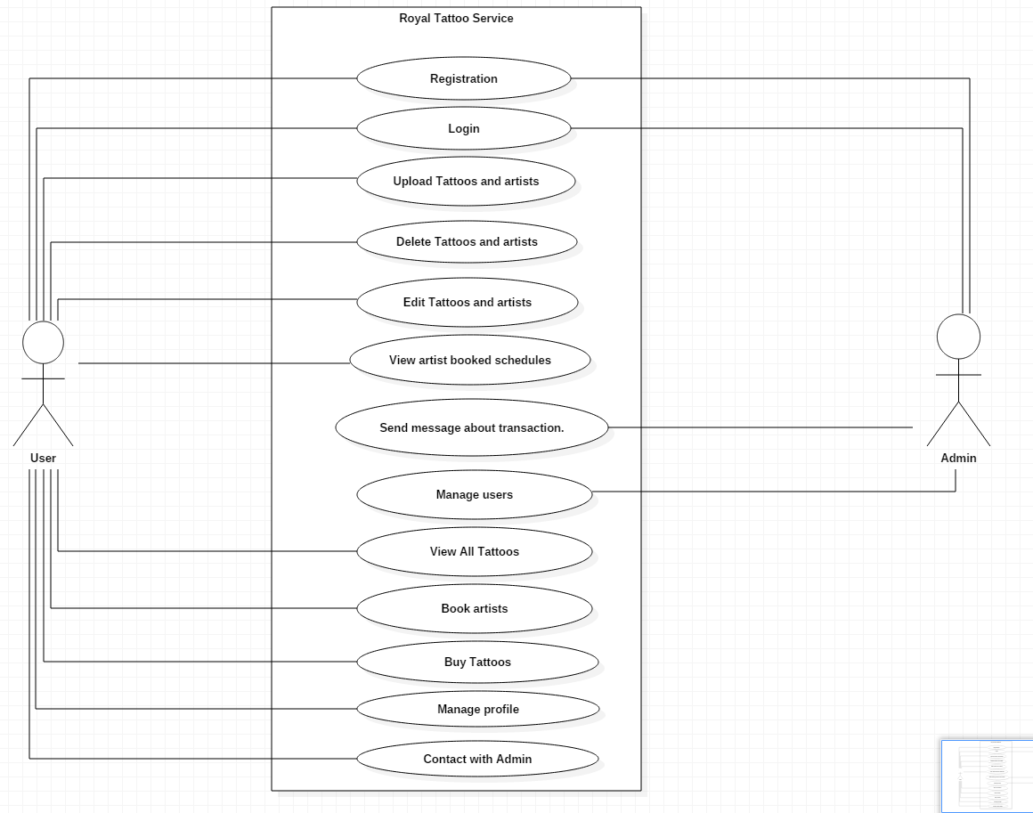

Figure 2 Use Case Diagram

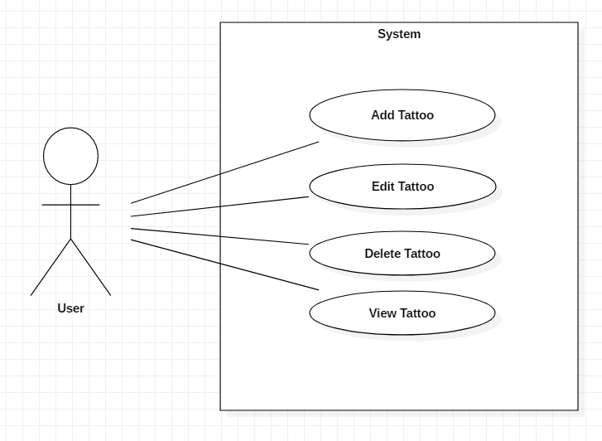

Figure 3 Use Case Diagram CRUDE

Title: “Add Tattoo”

|  |  |
| --- | --- |
| ID | AT3 |
| Justification | It is an important use case which adds data into the system. |
| Primary Actor | User |
| Secondary Actor | NA |
| Primary Flow | 1. User logs into the system with valid credentials. 2. User navigates into the View tattoo page. 3. User then clicks on the corresponding button for adding of tattoo. 4. User inputs all the necessary data needed in each field and submits the form. 5. System then validates and verifies the valid input. 6. System adds the data of the form into the database. 7. System then redirects to a page displaying all the tattoos. |
| Alternative Flow | 5.1 User inputs invalid data into the field of the form.  5.1.1 System shows that the data is incorrect or invalid.  5.1.2 User inputs the values again into the form.  5.1.3 Repeating of process from 4.1 until data is valid and correct. |

Title: “Edit Tattoo”

|  |  |
| --- | --- |
| ID | AT4 |
| Justification | It is an important use case which updates the data within the database of the system. Used for correction of data or changing of data. |
| Primary Actor | User |
| Secondary Actor | NA |
| Primary Flow | 1. User logs into the system with valid credentials. 2. User navigates into the View tattoo page. 3. User then clicks on the corresponding button for updating of data of the tattoo. 4. System then redirects to an update form where admin can update data. 5. User edits the data that needs to be updated and submits the form. 6. System then validates and verifies the valid input. 7. System updates the data of the form into the database. 8. System then redirects to a page displaying all the tattoos. |
| Alternative Flow | 6.1 User inputs invalid data into the field of the form.  6.1.1 System shows that the data is incorrect or invalid.  6.1.2 User inputs the values again into the form.  6.1.3 Repeating of process from 4.1 until data is valid and correct. |

Title: “Delete Tattoo”

|  |  |
| --- | --- |
| ID | AT5 |
| Justification | It is an important use case which deletes data within the database of the system. Used for deleting huge and irrelevant data from the system. |
| Primary Actor | User |
| Secondary Actor | NA |
| Primary Flow | 1. User logs into the system with valid credentials. 2. User navigates into the View tattoo page. 3. User then clicks on the corresponding button for deleting of data from the system. 4. System shows a dialog box which shows if you want to delete it. 5. User confirms to delete the data. 6. System deletes the data form the database. 7. System then redirects to a page displaying all the tattoos. |
| Alternative Flow | 5.1 User declines to delete the data.  5.1.1 System then redirects to a page displaying all the tattoos. |

Title: “View Tattoo”

|  |  |
| --- | --- |
| ID | AT6 |
| Justification | It is an important use case which views all the data from the database. |
| Primary Actor | User |
| Secondary Actor | NA |
| Primary Flow | 1. User logs into the system with valid credentials. 2. User navigates into the View tattoo page. 3. System redirects to a page displaying all the tattoos. |
| Alternative Flow | NA |

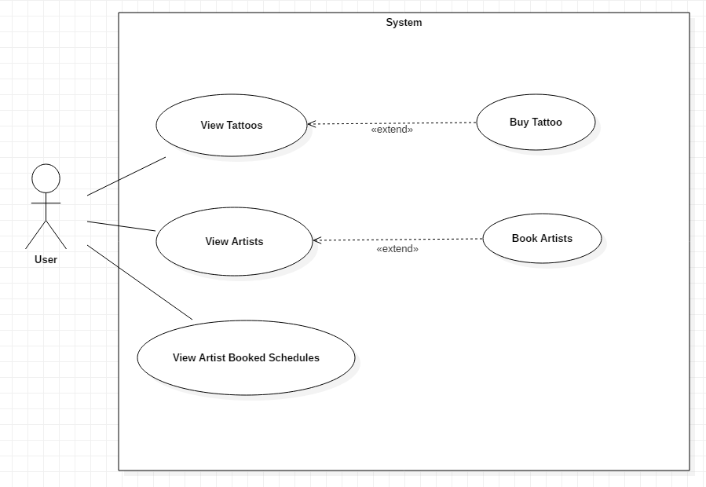

Figure 4 Use Case Diagram Viewing Artist and Tattoos

Title: “View Artists”

|  |  |
| --- | --- |
| ID | AT7 |
| Justification | It is an important use case which views all the artists available in the system. Here user can book artists. |
| Primary Actor | User |
| Secondary Actor | NA |
| Primary Flow | 1. User logs into the system with valid credentials. 2. User navigates into the View Artists page. 3. System shows all the current Artists in the system. 4. User then clicks on the corresponding button for booking of artist. 5. System shows a dialog box which shows if you want to book it. 6. User confirms to book the artist. 7. System books the artist and updates the data into the database. 8. System then redirects to a page displaying all the artists. |
| Alternative Flow | 5.1 User declines to book the data.  5.1.1 System then redirects to a page displaying all the artists. |

Title: “View Booked Artists”

|  |  |
| --- | --- |
| ID | AT8 |
| Justification | It is an important use case which shows all the booked artists within the system. Used for seeing if that artist is available or not. |
| Primary Actor | User |
| Secondary Actor | NA |
| Primary Flow | 1. User logs into the system with valid credentials. 2. User navigates into the View artists page. 3. System shows all the current Artists in the system. 4. User then clicks on the corresponding button for viewing booked artists. 5. System redirects to a page displaying all the booked artists. |
| Alternative Flow | NA |

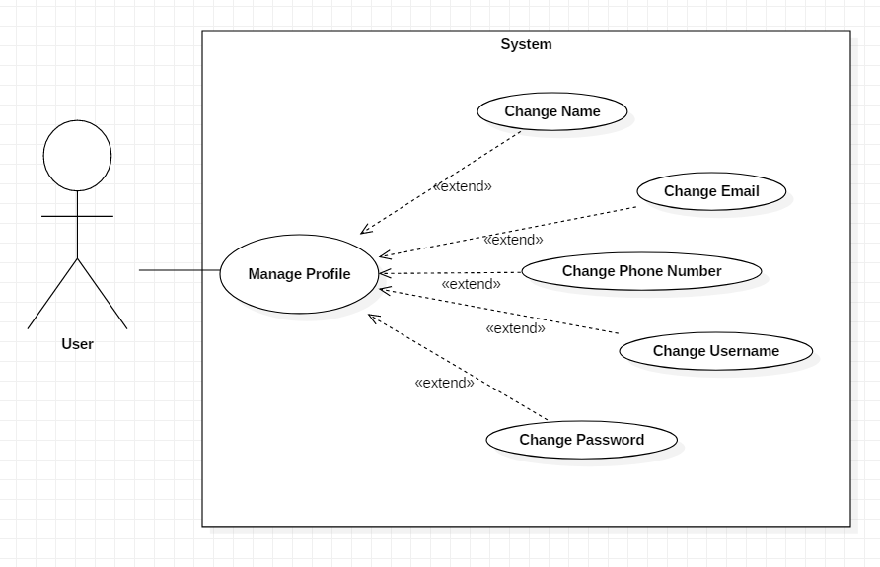

Figure 5 Use Case Manage Profiles

Title: “Manage Profiles”

|  |  |
| --- | --- |
| ID | AT9 |
| Justification | It is an important use case which manages the profiles of the users. |
| Primary Actor | Users |
| Secondary Actor | NA |
| Primary Flow | 1. User logs into the system with valid credentials. 2. User navigates into the Profile page. 3. User then clicks on the corresponding button for editing of information. 4. User inputs all the necessary data needed in each field and submits the form. 5. System then validates and verifies the valid input. 6. System updates the data of the form into the database. 7. System then redirects to the home page. |
| Alternative Flow | 5.1 Admin inputs invalid data into the field of the form.  5.1.1 System shows that the data is incorrect or invalid.  5.1.2 Admin inputs the values again into the form.  5.1.3 Repeating of process from 4.1 until data is valid and correct. |

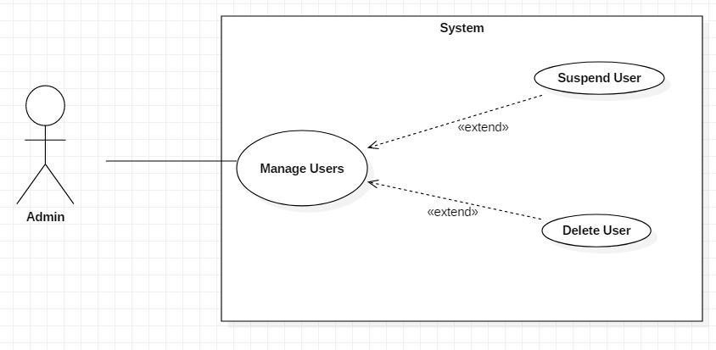

Figure 6 Use Case Manage Users

Title: “Manage Users”

|  |  |
| --- | --- |
| ID | AT10 |
| Justification | It is an important use case which manages user according to their behavior in the system. |
| Primary Actor | Admin |
| Secondary Actor | NA |
| Primary Flow | 1. Admin logs into the system with valid credentials. 2. Admin navigates into the View Users page. 3. System shows logs of Users. 4. Admin sees the logs and behaviors of users. 5. Admin then manage user according to that log. |
| Alternative Flow | * 1. Admin finds out bad behavior with low impact      1. Admin temporarily bans the user.      2. System Deactivates the user for a certain time.      3. System Redirects to the View Users Page.   5.2. Admin finds out bad behavior with high impact.   * + 1. Admin permanently bans the user.     2. System Deactivates the user for a certain time.   5.2.3 System Redirects to the View Users Page. |